DISC Profile (Self- Assessment)

INSTRUCTIONS

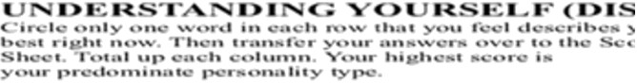
Understanding Yourself (DISC) Worksheet

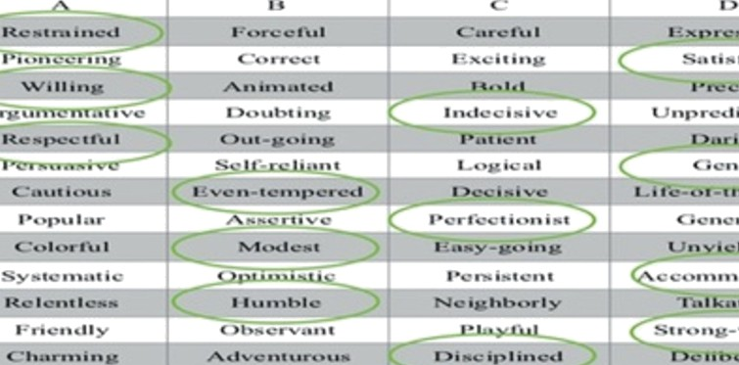
For each row, l -24, circle one word in each row that you feel best describes you rig ht now.

D-I-S-C Scoring Worksheet

For each answer you circled on the Understanding Yourself worksheet, circle the letter that corresponds to your answer. Once you have 1-24 completed total up the num ber in each colum n. The top of each colum n has a D-I-S-C. The colum n has the most circled is your dominant behavior style.

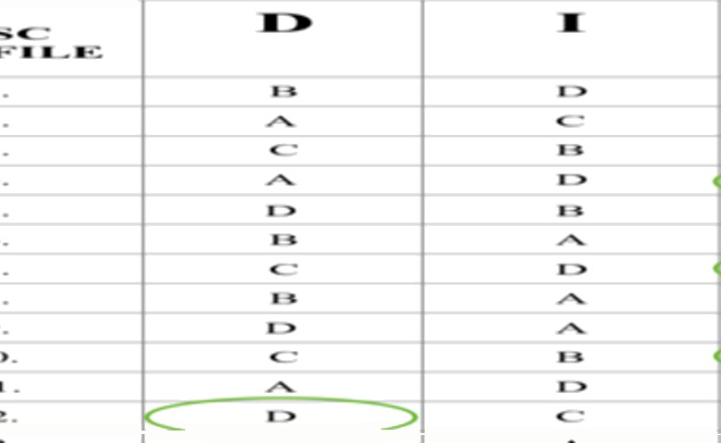

Recognizing Your Style

Use the Recognizing DISC Styles worksheet for identifiers in Your style and also learn identifiers for those outside of your style to im prove your communications across all styles.

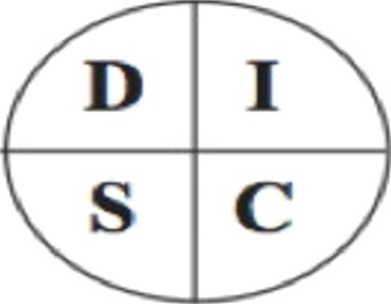
u»nERSTANDENc YOURSELF {DISC)
Circle only one word in each row that you feel describes you best right now. Then transfer your answers over to the Scoring Sheet. Total up each column. Your highest score is
your predominate personality type.

 | A |  |  | D
2. | Pioneering | Correct | Exciting | Satisfied
4. | Argumentative | Doubting | Indecisive | Unpredictable
6. | Persuasive | Self-reliant | Logical | Genfe
8. | Popular | Assertive | Perfectionist | Generous
10. | Systematic | Optimistic | Persistent | Accommodating
12. | Friendly | Observant | iayni | Strong-willed
14. | Restrained | Steady | Aggressive | Attractive
16. | Commanding | Impulsive | Slow-paced | Critical
18. | Influential | Kind | Independent | Orderly
20. | Impatient | Señous | Procrastinator | Emotional
22. | Self-sacrificing | Considerate | Convincing | Courageous
24. | Tolerant | Conventional | Stimulating | Directing

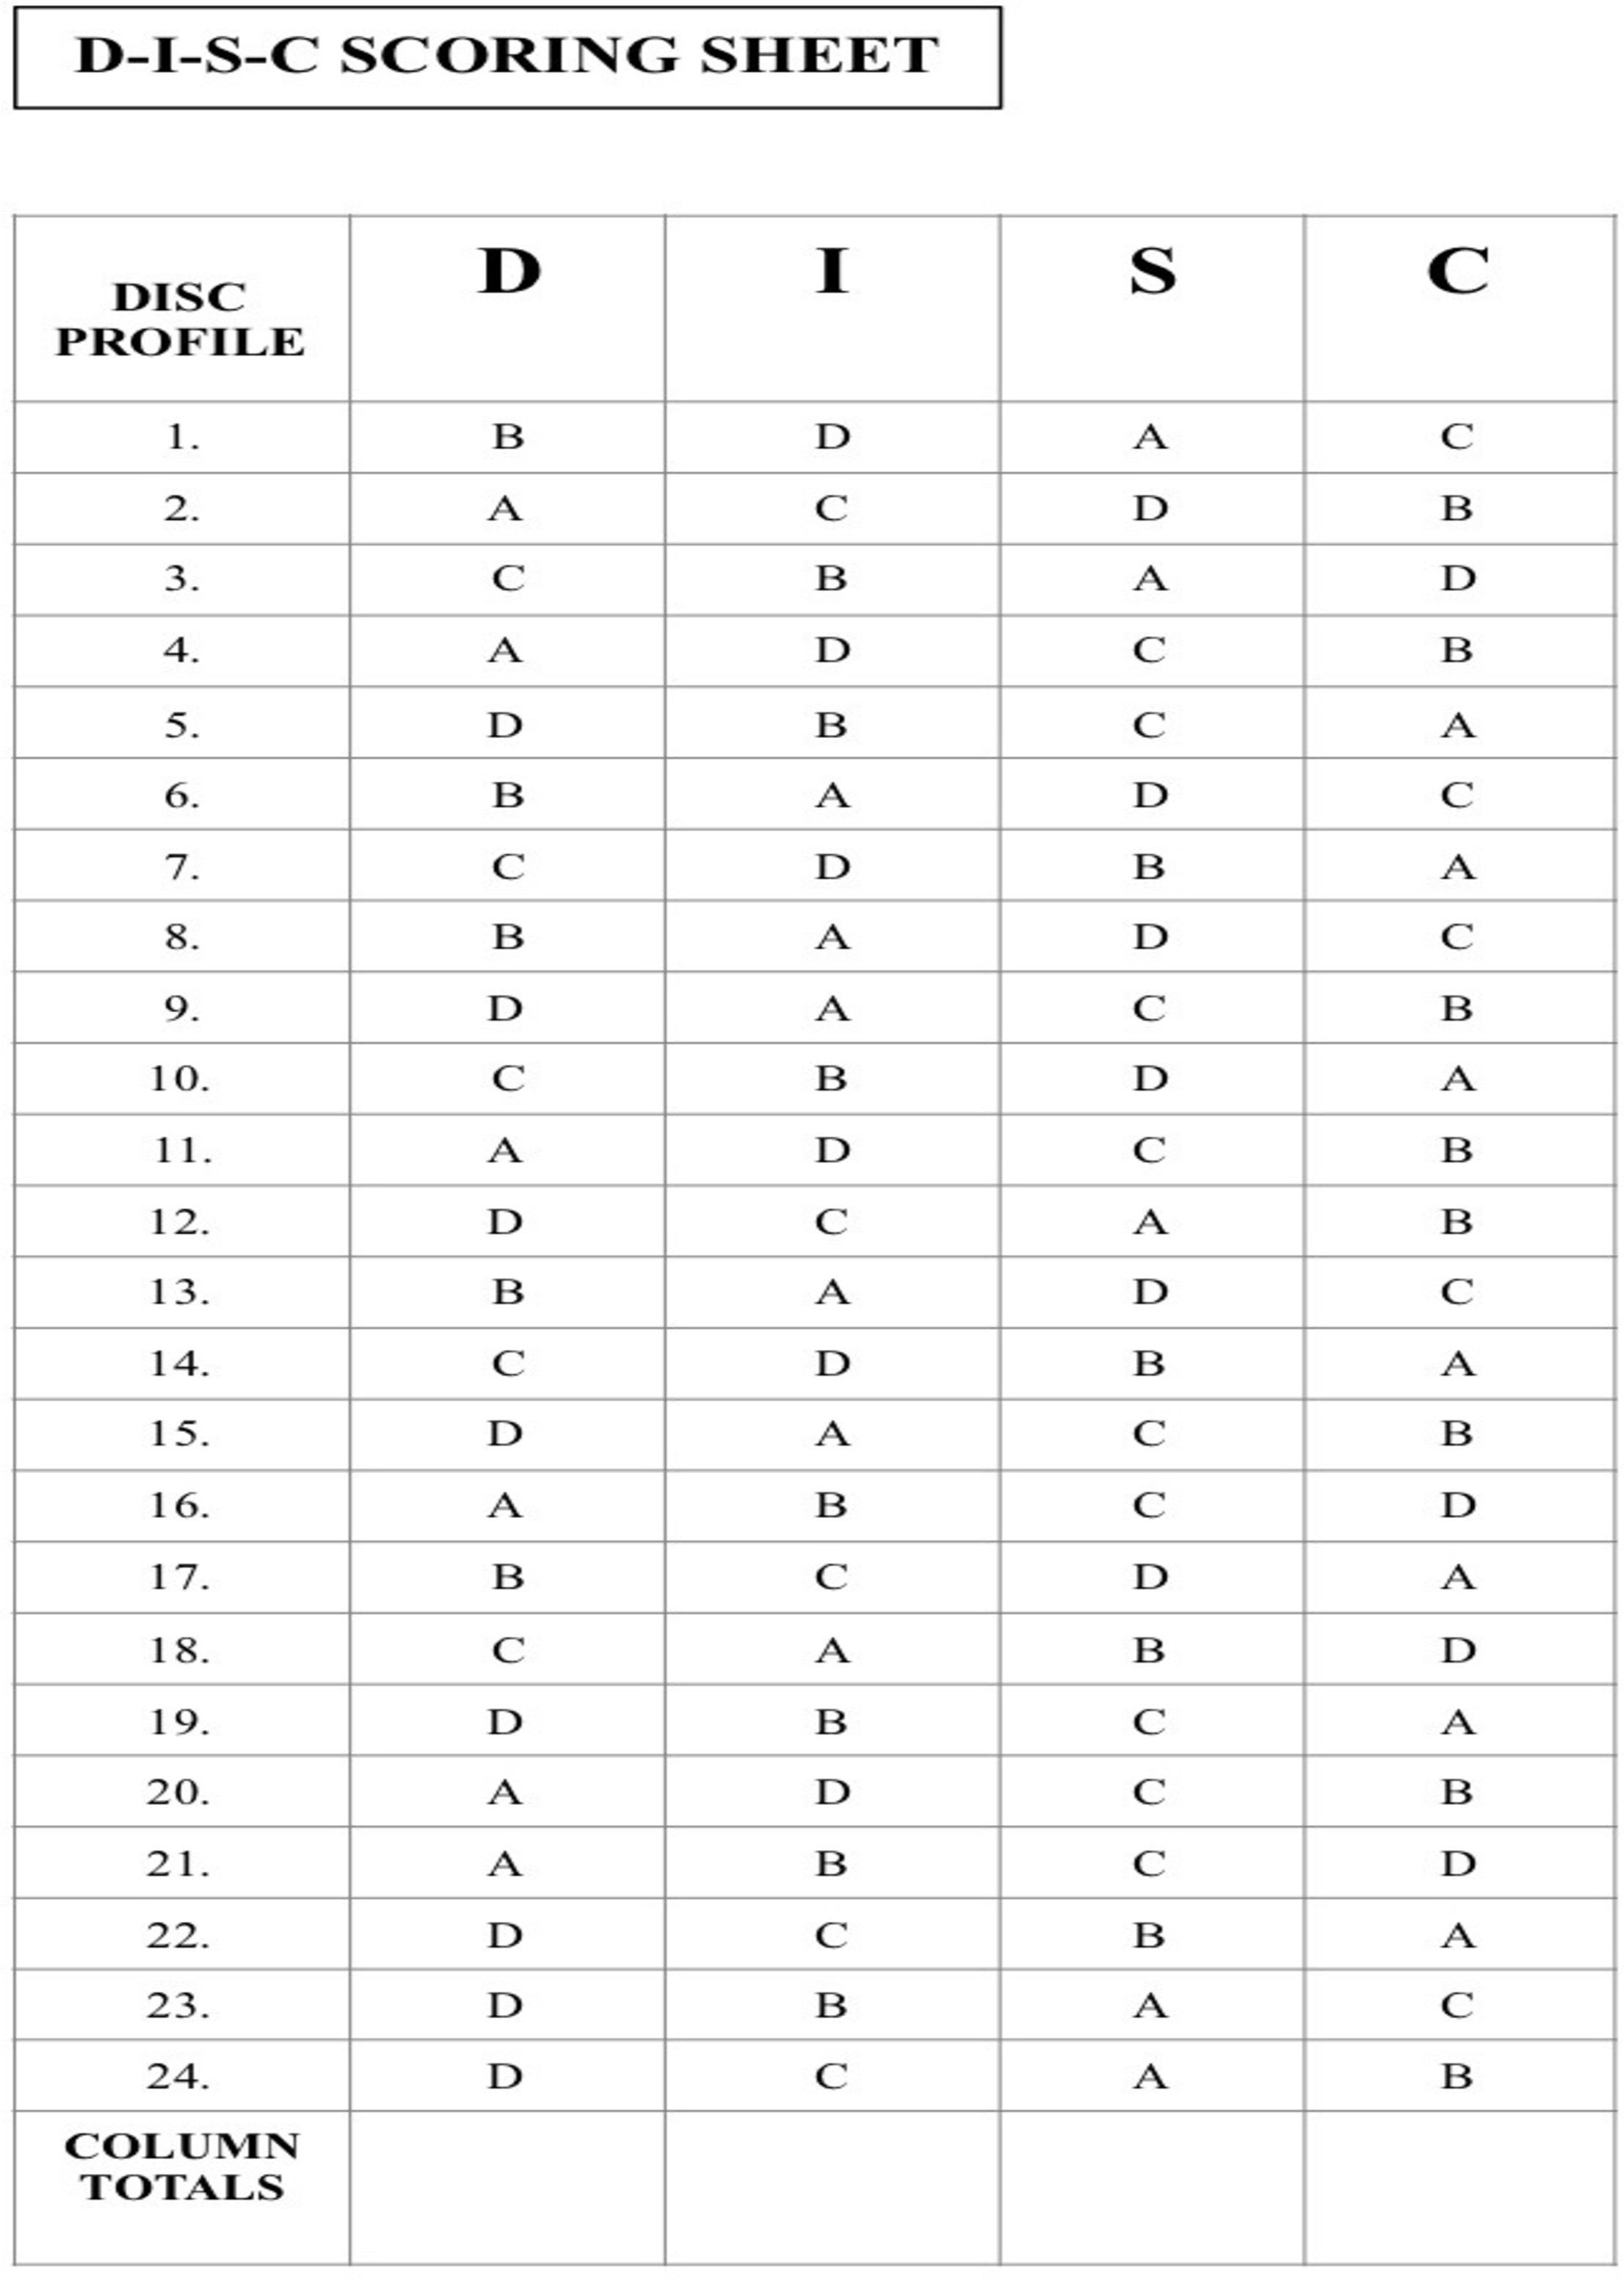

DISC Profile (Self- Assessment)

‹{[r RECOGNIZING DISC

The C is looking for: FACTS

Quick Observations: Slower paced, task-oriented Communication: Direct
Overextension: Critical

Organization: Everything in its place. Perfectly organized.

Body Language:
Stance - Arms folded, one hand on chin Walks - Straight line
Gestures - Very reserved, little or no gestures Communication Clue: Asks detailed questions


The S is look ing for: STABILITY

Ouick Observations: Slower paced, people-oriented

Communication: Indirect Overextension: Possessiveness
Organization: Usually some type of system. A little on the sloppy side.
Body Language:
Stance - Leaning back, hand in pocket Walks - Steady, easy pace
Gestures - Will gesture with hands Communication Clue: Has a “poker” face

2016 TTI S«ccess Insights

STYLES

The D is looking for: RESULTS

Quick Observations: Faster paced, task-oriented Communication: Direct
Overextension: Impatient
Organization: Efficient, not neat. Body Language:
Stance - Forward leaning, hand in pocket Walks - Fast, always going somewhere
Gestures - A lot of hand movement when talking, big gestures

Communication Clue: Doesn't want others' opinions, only facts

I INFLUENCE
The I is loo king for: INT ER ACTION

Ouick Observations: Faster paced, people-oriented

Communication: Indirect Overextension: Disorganized
Organization: Disorganized. A lot of piles.

Body Language:
Stance - Feet spread, two hands in pockets Walks - Weaves, people focused, may run into things
Gestures - A lot of big gestures and facial expressions when talking

Communication Clue: Talks with hands

121916

